Title or Task: | 

Description:

Files Required
Suitable for Classes: | AIT • Multimedia • Cert II IT • Cert II Bus
Area: | Technology & Enterprise
Teacher: | Mr Peter Faulks

Timeline

Date Due:

Task Brief:

Outcomes:

Items highlighted in yellow are tasks for you to complete
Items in Blue italics are help tips

APPLIED INFORMATION TECHNOLOGY
IN CLASS TEST

In Class Test - February 2011

Name: ________________________________________________

Teacher: Mr P Faulks

TIME ALLOWED FOR THIS PAPER:

Reading time before commencing: Five minutes
Working time for paper: Fifty minutes

INSTRUCTIONS TO STUDENTS

This paper is in two (2) sections.

Supplementary: Create a folder inside your AIT folder title this Test
(1 folder = 10 marks)
SECTION A: Multiple Choice. Attempt ALL questions
(10 questions = 10 marks)
Record your answer on the pages shown, save this document to your Exam Folder as your intials_test1
SECTION B: Create a graphic save to Exam Folder as
your intials_graphic1
(1 questions = 80 marks)

Note: All graphics are attached to this document (apart from your photograph)
SECTION A:
Save the completed Section A of this exam and any final work for marking to your folder called TEST in your workspace.
Highlight or indicate the correct answers for the following questions.

1 Below are two graphics. What graphic effect has been applied to graphic 1 to create graphic 2?

 | 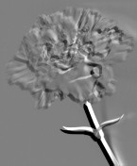
Graphic 1 | Graphic 2

- Gaussian blur
- Emboss
- Punch
- Monochrome

2 Which of the following techniques has been used to create Graphic 2 from Graphic 1?

 | 
Graphic 1 | Graphic 2

- Crop
- Transform
- Merge
- Re-sample

3 What is a disadvantage of digital convergence?

- Digital products are very expensive to make.
- Digital versions of products degrade with use.
- Portability and transmission.
- Cost of upgrading computer hardware and software to meet the demands of new products.

- Dan has downloaded a music file without paying and fee , which of the following may he be liable?

- The Privacy Act
- Piracy Laws
- Intellectual property
- Plagiarism

5. Here is a URL.

http://www.man.ac.uk/Science_Engineering/CHSTM/contents.htm

What part of the URL is the section “www.man.ac.uk”

- Host
- Protocol
- Page
- Path

6. The source country for the URL is:-

- Australia
- United States of America
- Great Britain
- None of the above

7. A web site has the URL http://www.wombat.com.au/wombat/series/daa/links.html
The first word in the path is:-

- www
- Wombat
- Series
- daa
8. What is the primary reason a good web designer would keep digital images small on a web-site?

- They are easier to see on the screen
- It is easier to read the text next to them
- They will allow the page to load faster because of the smaller file sizes
- They make the presentation look far more professional

9. Which list refers only to peripherals that are ALL input devices
(i.e.: input to computer)?

- Flatbed scanner, USB thumb drive, keyboard, data projector
- USB photo (downloading), firewire video (uploading to camera), LCD touch-screen, scanner
- Video camera (downloading), bar-code reader, webcam, keyboard
- LCD touch screen, speakers, colour laser printer, webcam

10. Which of the following series contains only possible audio file formats?

- .midi, .aud, .wav, .pdf
- .mp3, .aud, .midi, .wav
- .mp3, .bmp, .wav, .mp4
- .jpg, .mov, .mp3, .wmp

End of Section A
PART B
Practical Create a Graphic
Using at least four or more of the eight (8) graphics below, plus your own photo - create an advertisement about any topic use any suitable software. Save as your intials_graphic1 to your TEST FOLDER
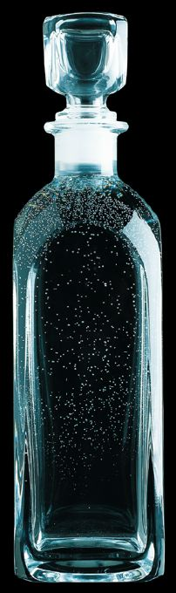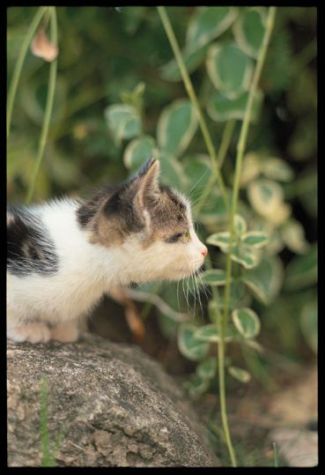

Images to use in AIT 2a PRACTICAL

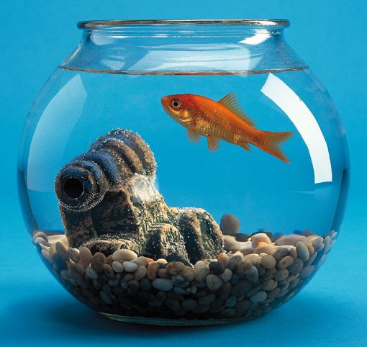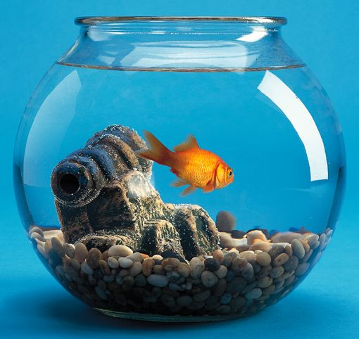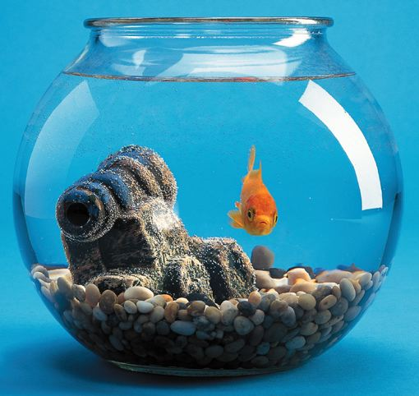

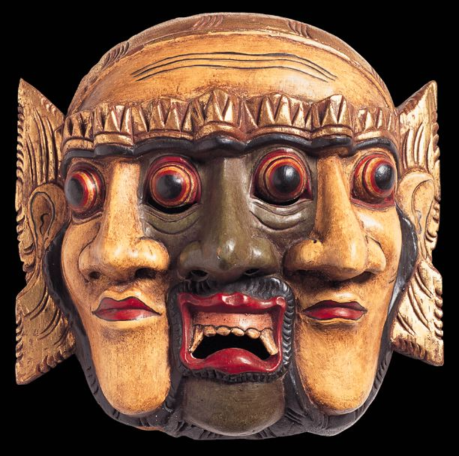


YOUR PHOTO
from your workspace - ESSENTIAL

